Cubism VR

The second part is a puzzle game based on rubik's cube, where the player is imprisoned in an inverse cube, where it is randomly scrambled and the player has to solve the cube to escape. Using their head movements, the player can observe the world around them to check for the colors and designs of the cube and by clicking on the button, drag the faces around to solve it.

Gameplay Mechanics:

1. Cube room
   1. Solve a rubik's cube
   2. Cube explodes and player enters the archives
2. Less time taken = higher score

**User Interface (UI):**

Time taken to solve the level

Shuffle button

Solve button

Task list

1. Complete rubiks cube
   1. Piece selection
   2. Rotation=
   3. Detection=

Raycasts to be on a +1 bias on each face, accounting for the neighbor face edges as well as the rotational data

Bugs:

Pieces randomly change position and merge together

1. Suspected cause of too many hierarchy changes, laggy, causes the parents to not be changed in time
2. Test fix 1: remove the second return phase, force the raycast to destroy after 1 time
3. Test fix 2: add a coroutine that locks player input and to make sure that only 1 rotation call is made every frame

Buttons only work once

1. Suspected use of euler prevents multiple changes to the rotation value
2. Test fix 1: add a recursive check to make sure that the value has incremented before changing again

Further development:

Hovering causes the reticle to change size and fill up gradually

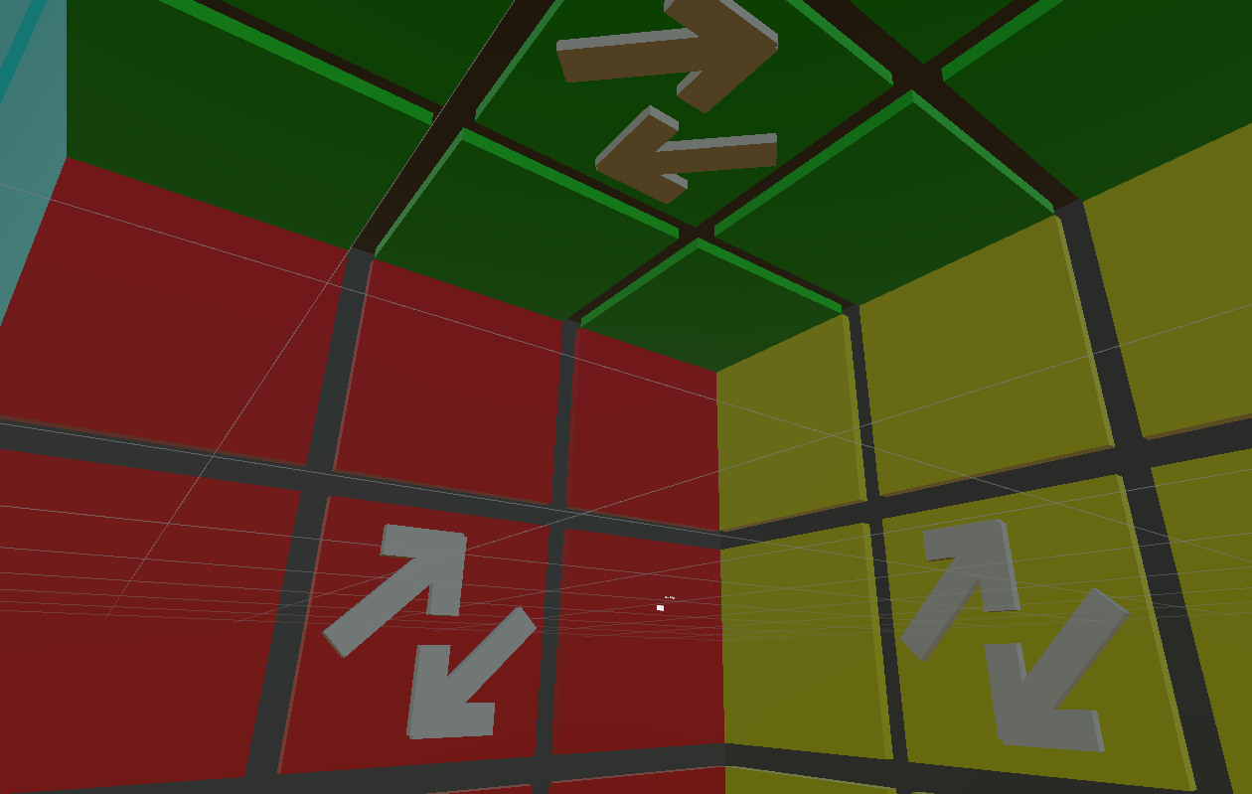

Inner Cube

Arrows depict the direction of the rotation

I am aware that both points clockwise, but other shapes look bad